Berwyn Presbyterian Church
13th Sunday in Ordinary Time
Sunday, June 28, 2020 10:30 am

THE GATHERING
Let all enter worship in a spirit of prayer.
Please remember to turn off your cell phones for worship.

Prelude “Softly and Tenderly Jesus Is Calling” Will L. Thompson

Ringing of the Hour

Prelude “I Heard the Voice of Jesus Say” English County Songs

Lighting of the Christ Candle

Welcome Rev. Laura Hollister

Call to Worship Godlove Mbah
Leader: Come from the fields of your daily labors, return from the journeys
That have taken you far from home-
Come, here is rest and renewal
People: We gather, hearts ready to receive God’s life-giving Word.
Leader: Come to this table, where all find welcome, and this font, where
Grace overflows-
Come into the presence of the Living Lord.
All: We come to praise God-
The sender and the sent.

Hymn GG 393 “O Day of Rest and Gladness”

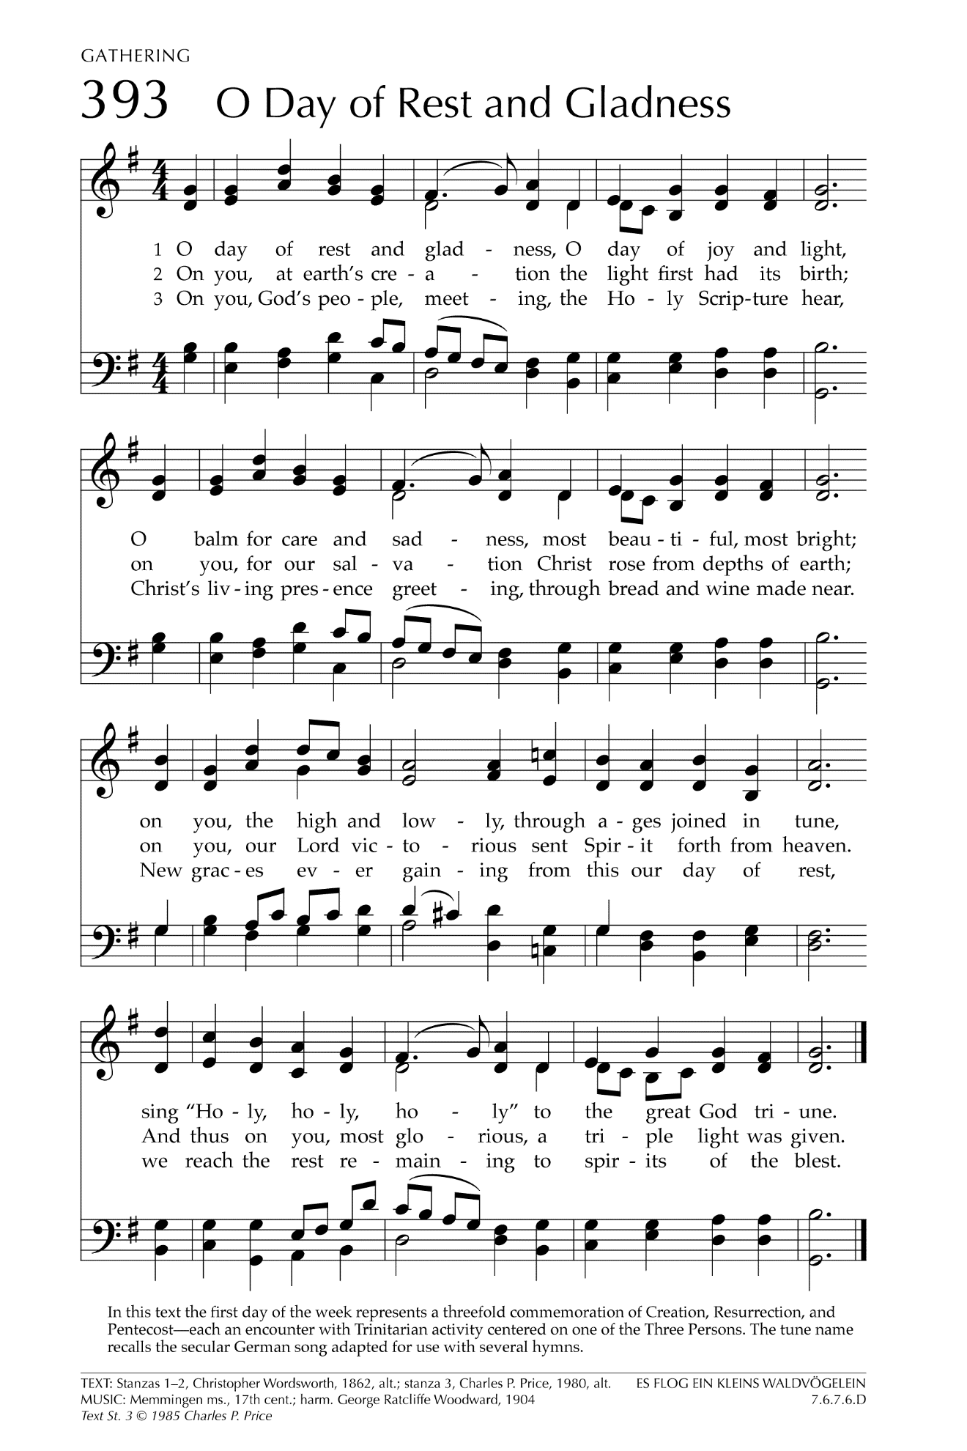
Call to Confession

Prayer of Confession (first pray silently, then in unison)
God, you send us as prophets to proclaim your coming reign. You send us out as witnesses to embody your justice, kindness, and mercy. Yet we shrink from your call to serve as messengers of your kingdom. We cling to safe surroundings and turn from the demands of discipleship. Forgive us, we pray. Embolden us, and send us again as heralds of your good news. In Jesus’ name we pray, Amen.

Declaration of Forgiveness

The Peace
Leader: May the peace of the risen Christ be with you always.
People: And also with you.
(Please share the peace with a few neighbors.)

Welcome Song “You’re Welcome in the Name of the Lord” Trad’l Cameroonian
You’re welcome in the name of the Lord, you’re welcome in the name of the Lord,
For we see in you the glory of the Lord, you’re welcome in the name of the Lord.
We love you in the name of the Lord (repeat)

THE WORD

Prayer for Illumination Godlove Mbah

Psalm 13 Hear what the Lord is saying to the Church.
Amen!

Matthew 10:40-42 This is the word of the Lord!
Thanks be to God!

Children’s Message Rev. Laura Hollister

Genesis 22:1-14 Hear what the Lord is saying to the Church.
Amen!

Sermon The Lord Will Provide

Hymn GG 465 “What a Friend We Have in Jesus”
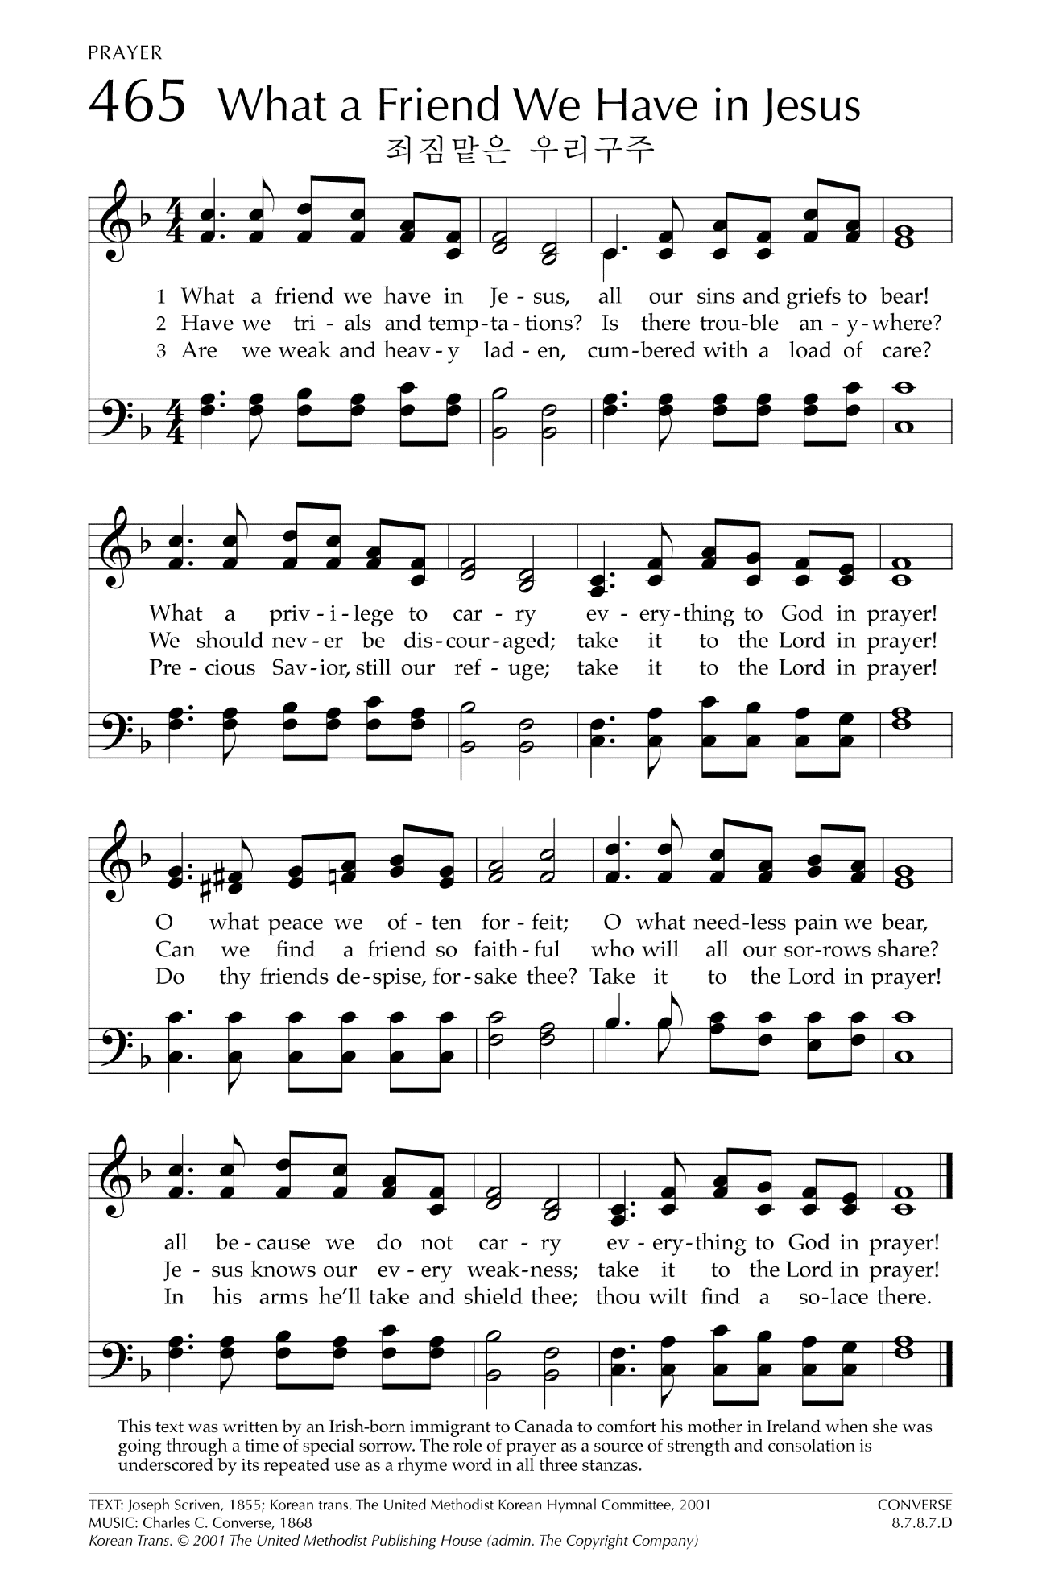
Sharing of Prayer Concerns/Morning Prayer

The Lord’s Prayer (traditional)
Our Father, who art in heaven, hallowed be thy name, thy kingdom come, thy will be done, on earth as it is in heaven. Give us this day our daily bread. And forgive us our debts, as we forgive our debtors. And lead us not into temptation, but deliver us from evil. For thine is the kingdom, and the power, and the glory, forever. Amen.

Announcements

THE THANKSGIVING

Call for the Offering

Prayer of Dedication

THE SENDING

Hymn GG 463 “How Firm a Foundation”
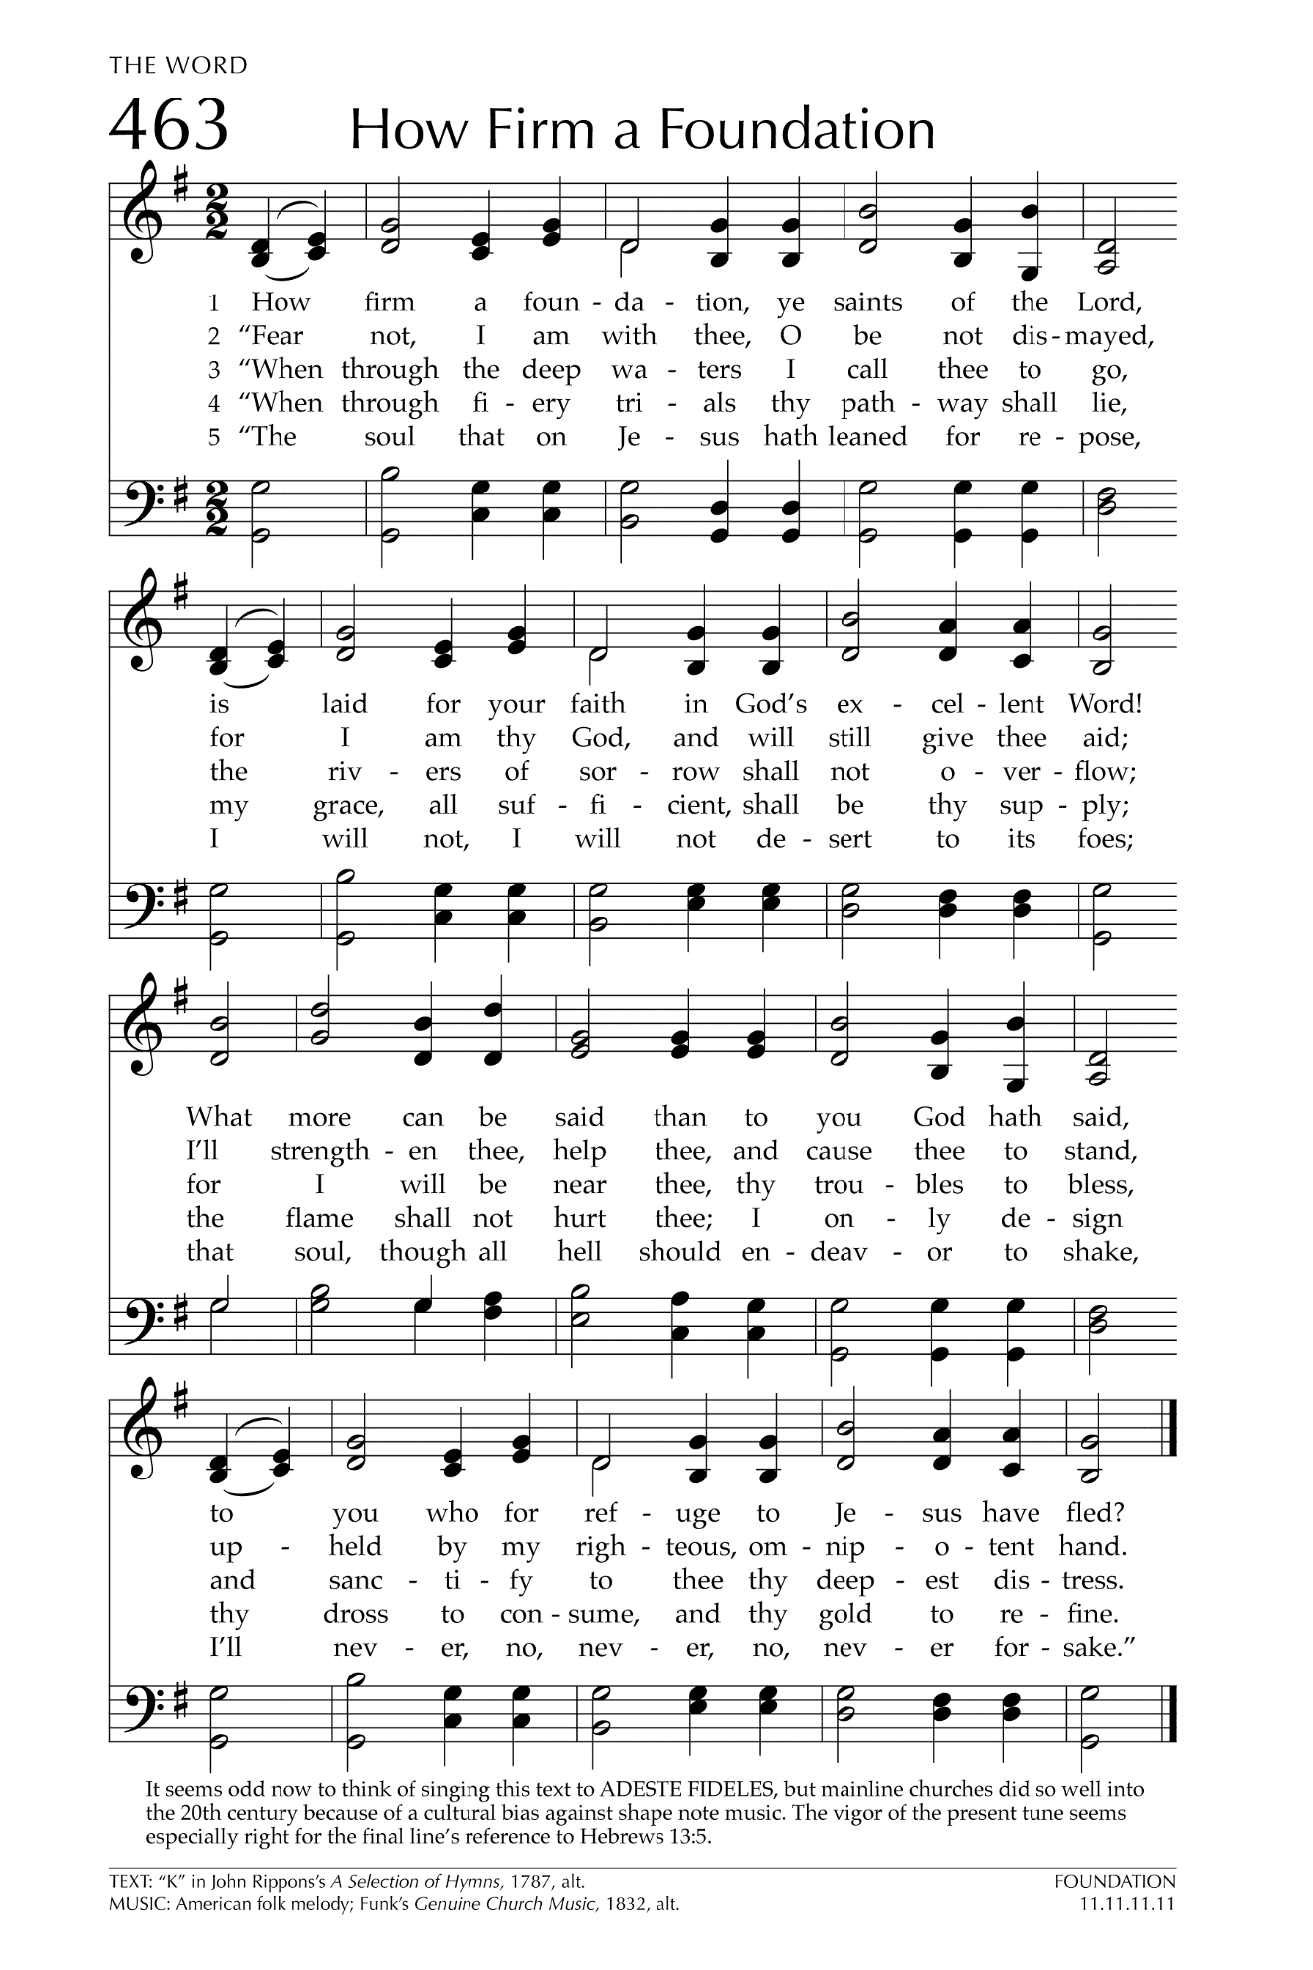
Benediction

Congregational Response “God Is So Good” Anonymous
God is so good, God is so good, God is so good, God’s so good to me.

Postlude “Fugue in E minor” Johann Sebastian Bach

Thank you for joining our online service today. We are delighted for the opportunity to worship God with you. Please feel at home and join us again. Visitors are encouraged to drop us a line at our church website: https://berwynpresbyterianchurch.net, or to write to the church email address: berwyn.office@gmail.org. We would love to be in touch.

Leading Worship Today:
Rev. Laura Hollister, Pastor
Dr. Gabriel Ruiz-Bernal, Music Director
Godlove Mbah, Worship Associate
Zandra Brown, Choir Member, Soloist

